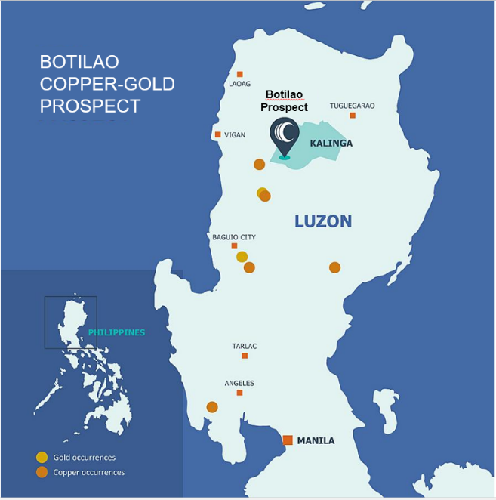
BOTILAO COPPER-GOLD PROSPECT
The Botilao Porphyry Copper-Gold Prospect is held by Makilala Mining Company, Inc., Celsius’ Resources’ Philippine subsidiary, which is located in the Cordillera Administrative Region, approximately 320km north of Manila. It is a prospect within the Makilala portfolio with a tenement area of 947.67 hectares, southwest of the MCB Project.
Historical exploration work conducted by Lepanto Consolidated Mining Inc. in the ‘70s includes drilling diamond bore holes and geochemical sampling along exploratory tunnels. A 1973 inspection and verification report by the Bureau of Mines indicated that Lepanto was able to delineate two (2) major ore zones striking northeast. Drilling and exploration tunnel works were concentrated around Botilao Creek, south of Pasil River. The report indicated tunnel samples with copper grades up to ~1%.
Location map of the Botilao Prospect in Northern Luzon, Philippines
The result of historical exploration works and the current understanding of the MCB Deposit will provide the initial working model for the Botilao Prospect.
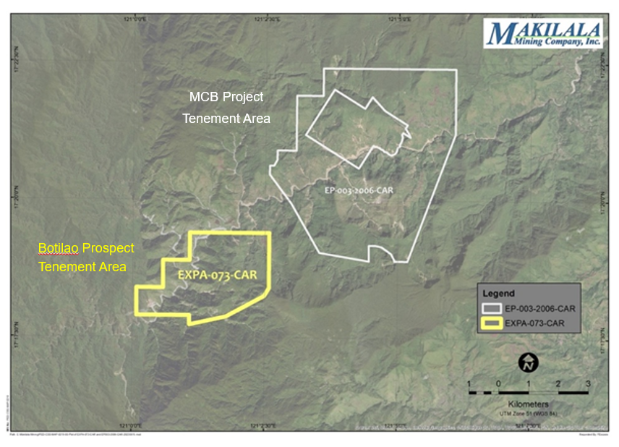
Exploration permit was granted on 4 August 2023 for a period two years. Exploration works will consist of regional to semi-detailed geochemical sampling and mapping to generate future targets for possible geophysical surveys and eventual diamond drilling activities. Mapping of different rock types or lithologies in the area will be conducted to characterize and delineate mineralised or altered zones. Detailed mapping will focus on identified mineralised outcrops to ensure proper understanding of the classification and controls of mineralisation.
Location of the Botilao Tenement with respect to the MCB Tenement.

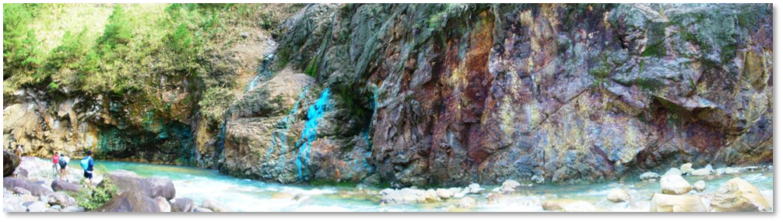

Almogela, D. H. (1973) Report on the Inspection and Verification of the Exploration Activities of Lepanto Consolidated Mining Company, Bureau of Mines, 16-18 March 1973.

